PROJECT-7:

Creating a peering connection between instances:

* A peering connection allows you to establish a private network connection between two Virtual Private Clouds (VPCs) in the same AWS region or in different AWS regions.
* It enables resources within the connected VPCs to communicate with each other as if they were on the same network.

VPC Requirements:

* Ensure that both VPCs have non-overlapping IP address ranges and do not have overlapping CIDR blocks.
* Also, make sure that the security groups and network ACLs associated with the subnets allow the necessary inbound and outbound traffic for the peering connection.
* Identify one VPC as the "requester" and the other as the "acceptor." The requester initiates the peering connection request, and the acceptor accepts or rejects the request.
* In the AWS Management Console or through the AWS CLI/APIs, create a peering connection request from the requester VPC to the acceptor VPC.
* Provide the necessary details such as the VPC IDs and the CIDR blocks of the VPCs.
* In the acceptor VPC, review and accept the peering connection request. You can either accept it manually or automate the acceptance using AWS CLI/APIs.

STEPS:

1.Create a VPC1 10.0.0.0/16 in N. Virginia region.

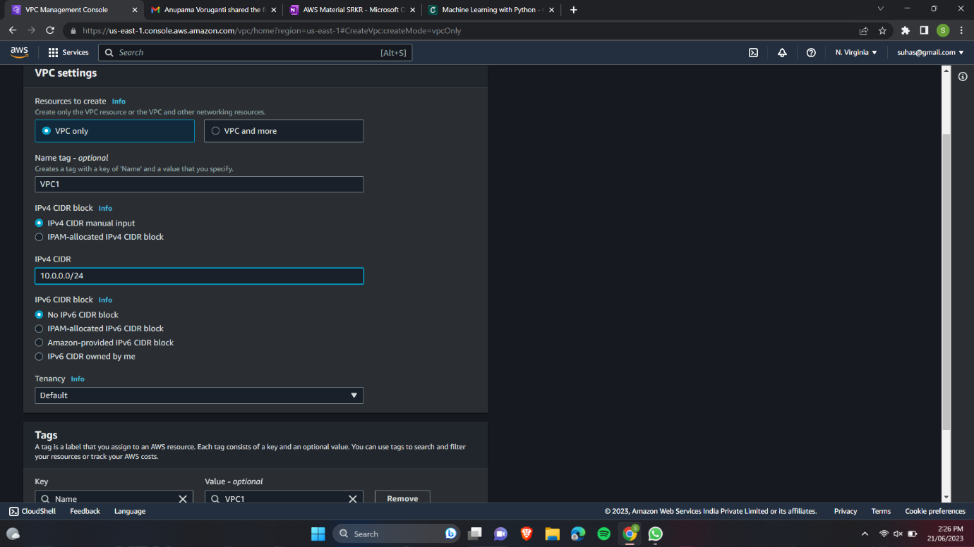

2.Create Subnet 10.0.1.0/24 in VPC1 1a AZ.

3.Create internet gateway.

4.Attach Internet gateway to VPC1.

5.Add Internet gateway as a route to VPC1 "main" route table with destination 0.0.0.0/0.

6.Associate VPC1 Subnet to Main Route table.

7.Create a VPC2 192.168.0.0/16 in N. Virginia region.

8.Create Subnet 192.168.1.0/24 in VPC2 1a AZ.

9.Create internet gateway.

10.Attach Internet gateway to VPC2.

11.Add Internet gateway as a route to VPC2 "main" route table with destination 0.0.0.0/0.

12.Associate VPC2 Subnet to Main Route table.

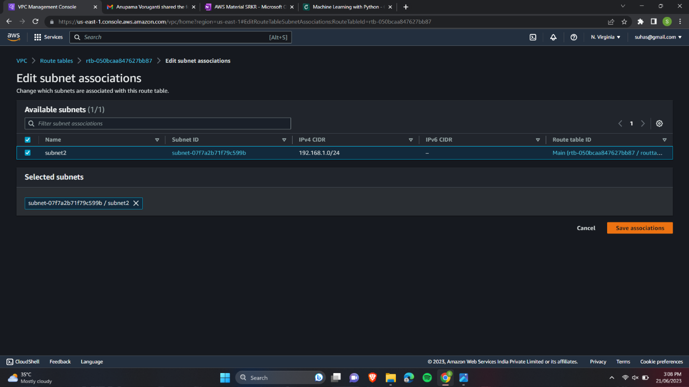

13.Creating inst1 in VPC1 and inst2 in VPC2.

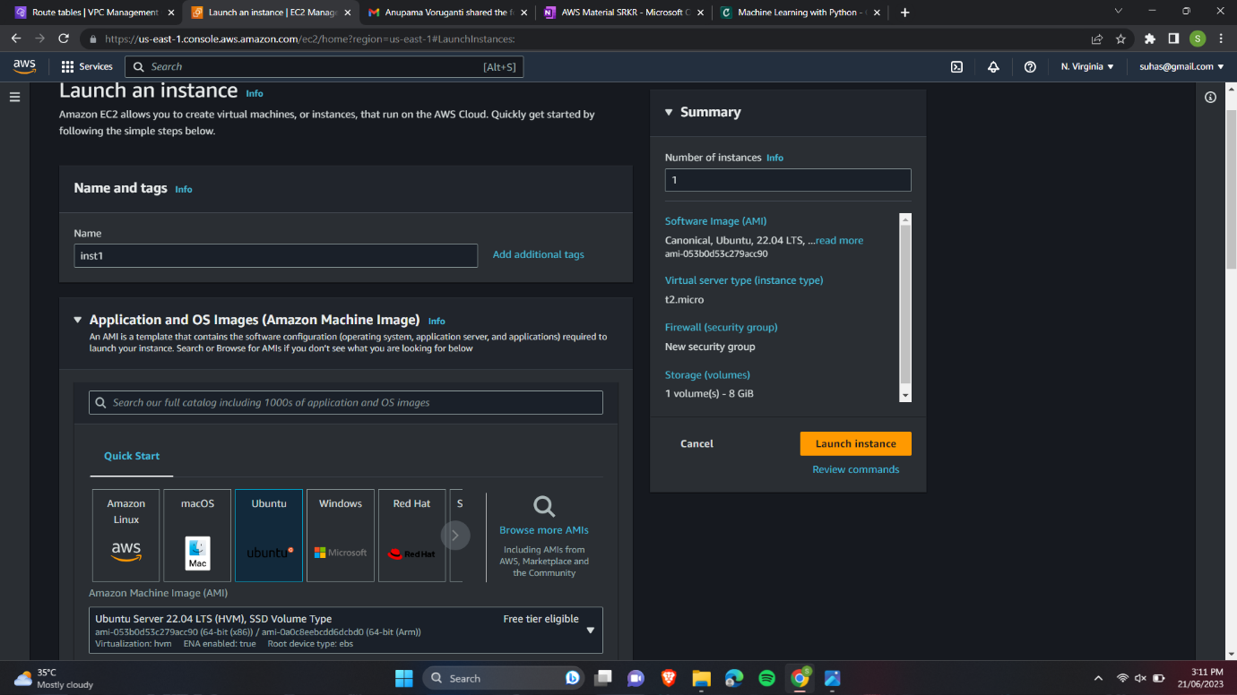

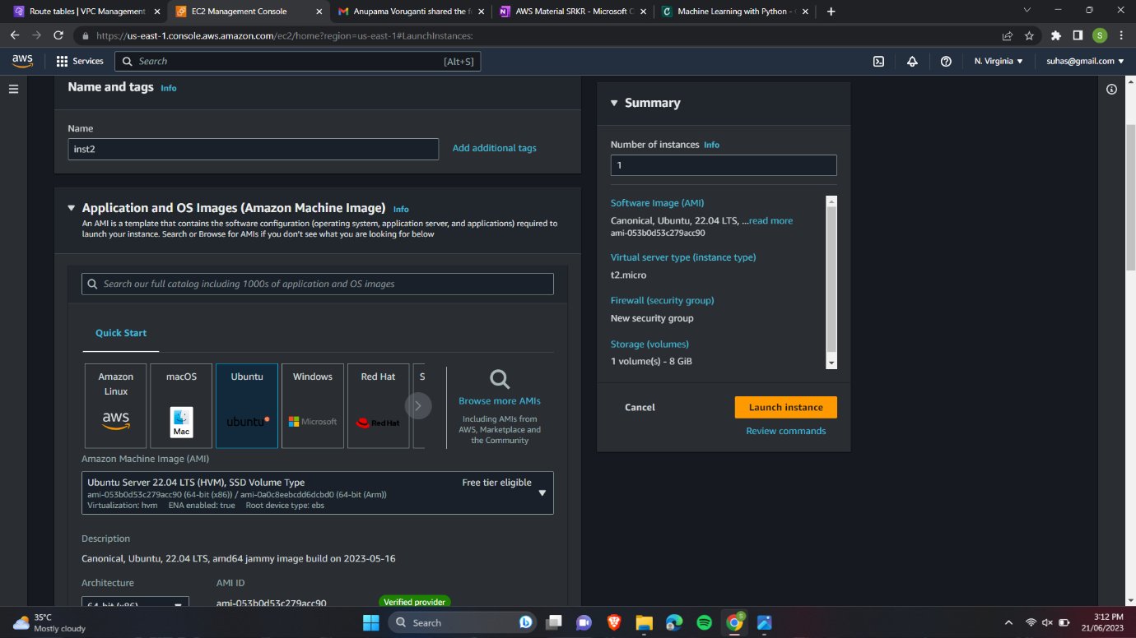

14. Create a peering connection between VPC1 and VPC2.

15. Accept the request.

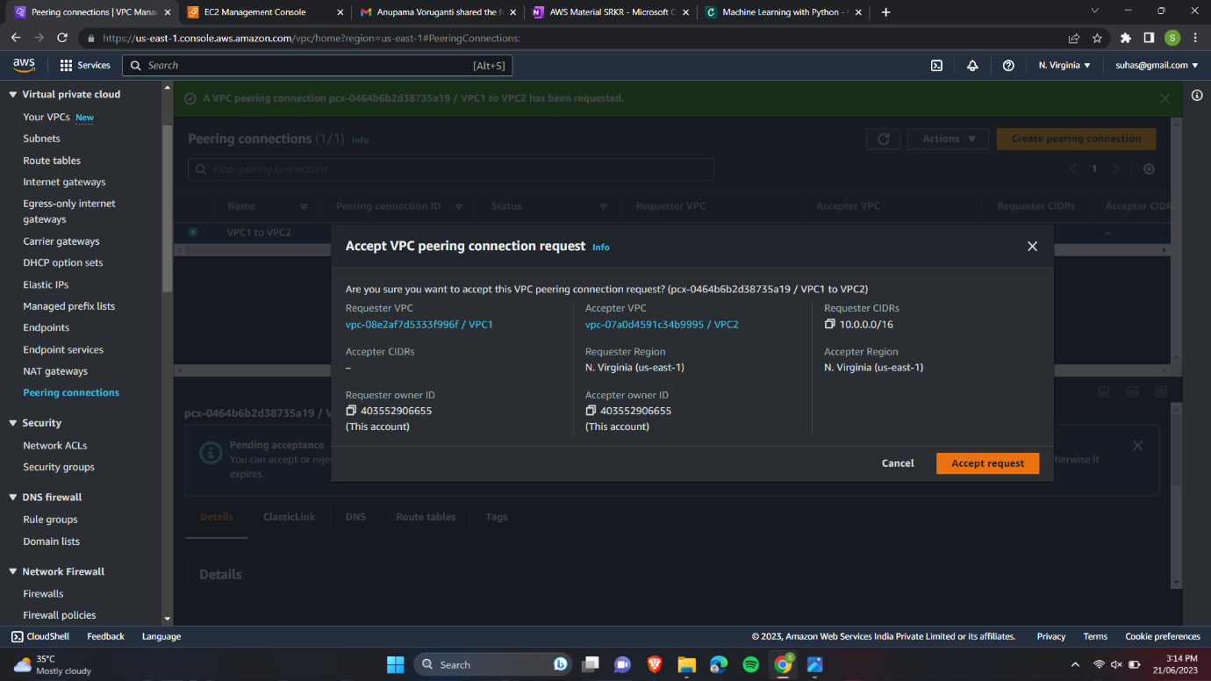

16. Add the peering route in VPC1 Main route table.

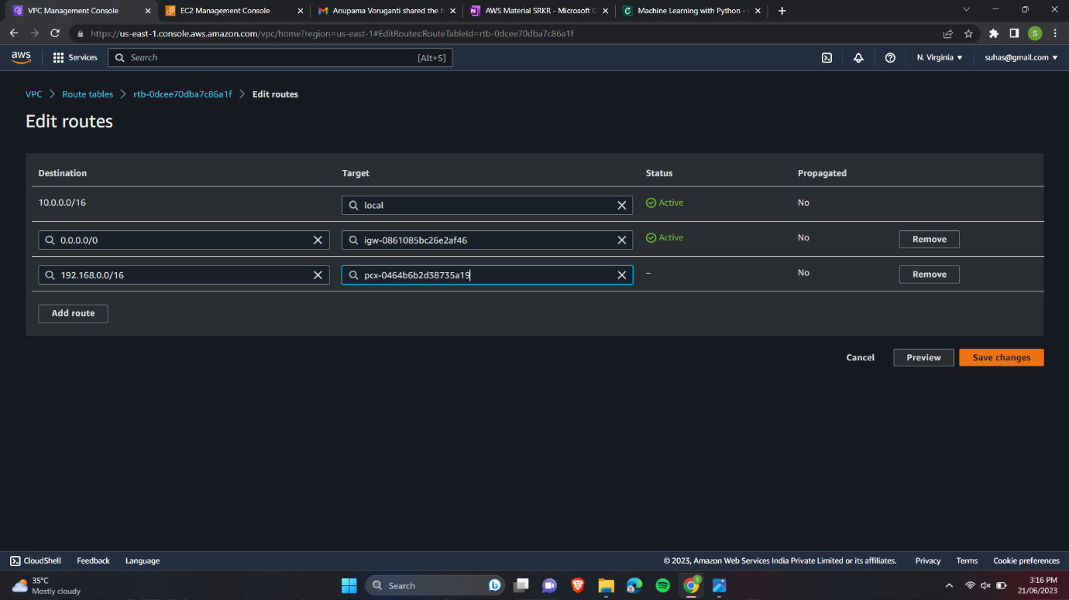

17. Add the peering route in VPC2 Main route table.

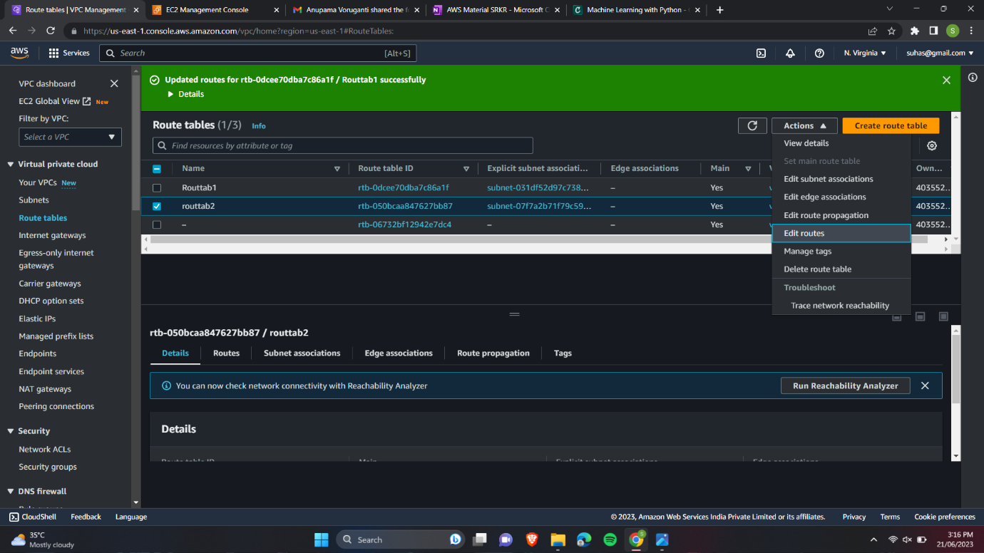

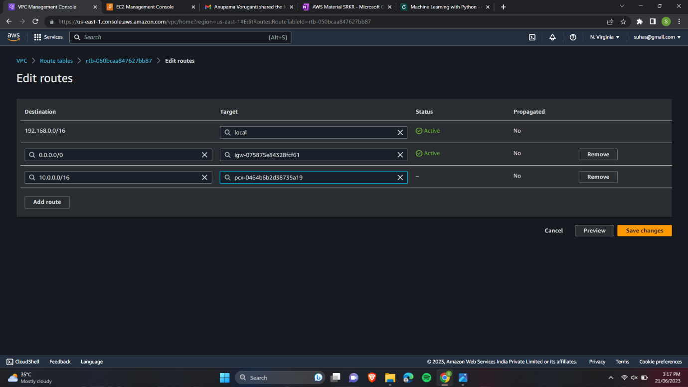

18. Connecting to our public instance using git-bash.

19. Updating our Ubnutu using sudo apt-get update.

20. Changing the permissions of opt folder and logging out of our instance.

21. Copying the key-pair file of private instance into the opt folder of public instance. And connecting to public instance.

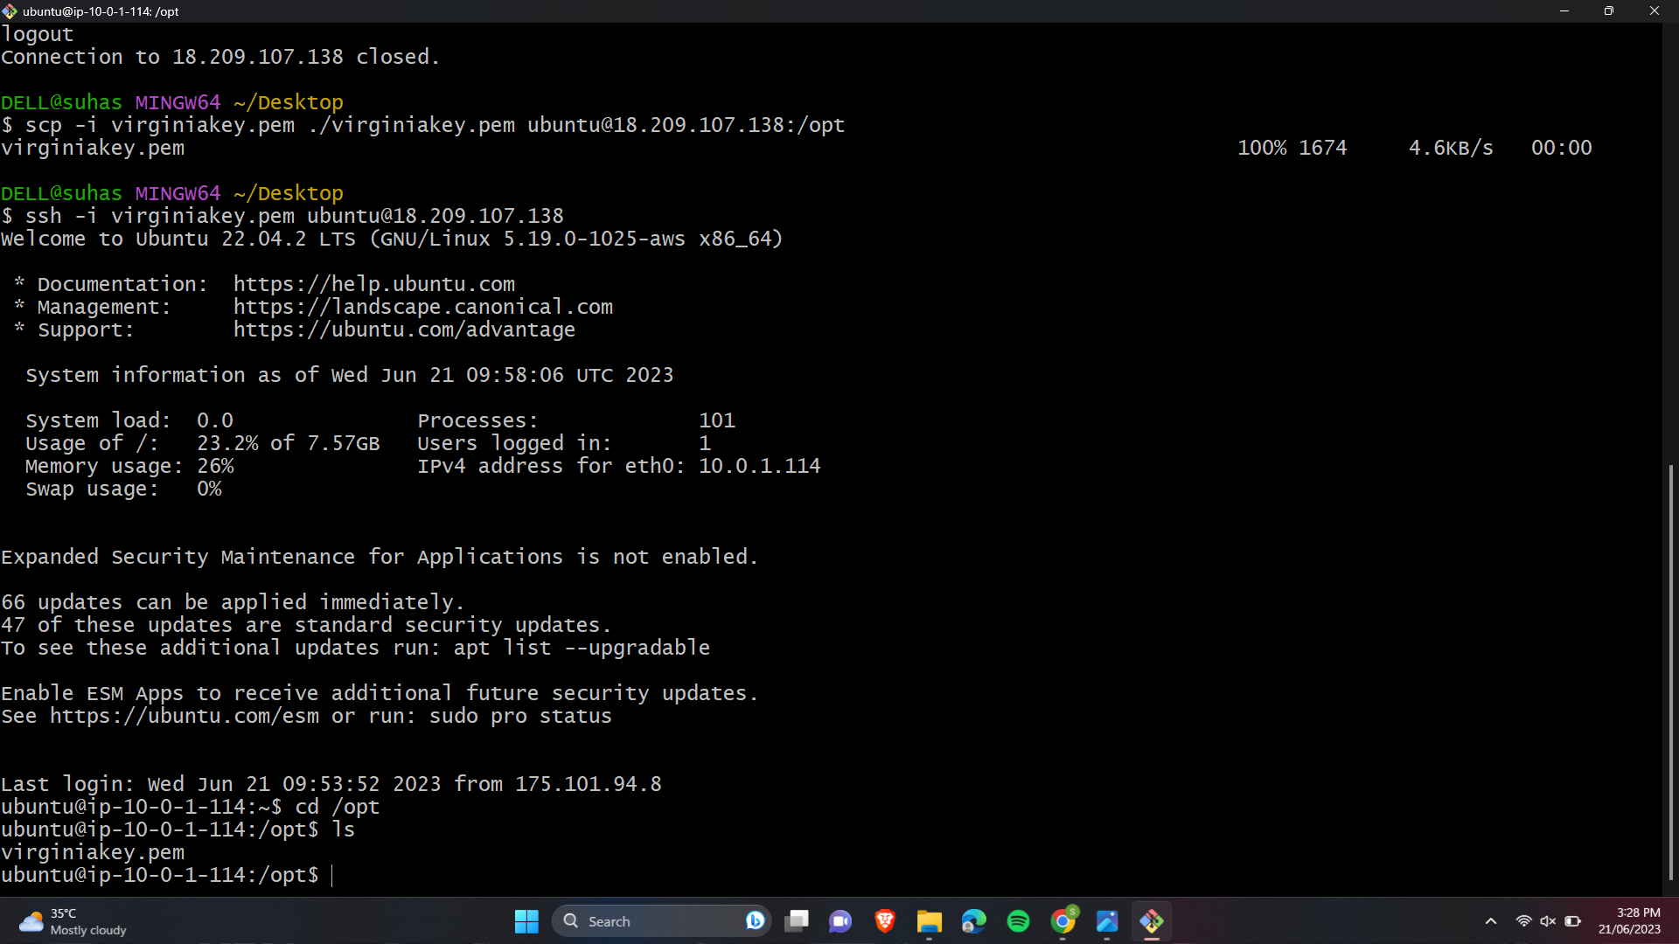

22. Changing the permissions of private key-pair file and connecting to private instance. Now if you try ping google.com you can see the traffic.

